8.1 Editors - Image Editor - Header
Detailed Table of content 1
Image Editor 13
Navigating in the Image Editor viewport 13
Sub Modes 14
Header - View Menu 14
Header - Image menu 16
Header - Select menu 19
Header - UV's menu 20
Header - Mask menu 21
Header tools 23
Header - UV Editing 28
Tool Shelf - Grease Pencil 32
Grease Pencil - Properties Sidebar - Layers Panel 43
Properties Sidebar - Grease Pencil - Colors Panel 47
Tool Shelf - Scopes Tab 49
Properties Sidebar - Image panel 51
Properties Sidebar - Game Properties panel 56
Properties Sidebar - Display panel with Image 57
Tool Shelf - Tools Tab - UV Editing - Snap panel 57
Tool Shelf - Tools Tab - UV Editing - UV Align panel 58
Tool Shelf - Tools Tab - UV Editing - UV Tools 61
Tool Shelf - Tools Tab - UV Editing - Transform panel 66
Tool Shelf - UV Editing - Options Tab - Options Panel 70
Tool Shelf - UV Sculpt - Tools Panel 70
Properties Sidebar - UV Editing 73
Applying Textures 76

Detailed Table of content

Image Editor - Header

The Header contains various menus, navigation elements, settings and tools for the 3d view. This content differs, dependant of the sub mode.

The header is divided into two areas. Left mode and menus. Right settings.

Header right click menus

The general right click menu functionality is explained in chapter 6 Editors introduction.

Editortype Menu
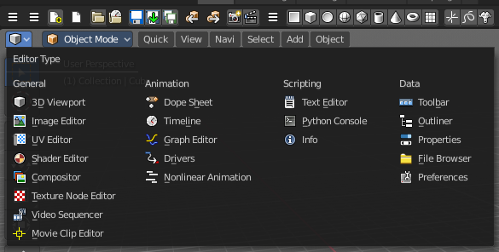
Bforartist is made of several editor types. Headers can display a menu where you can switch to other editor types.

This menu is hidden by default. It is meant to edit the layouts, and should not be necessary for regular work. You can reveal it in the header right click menu.

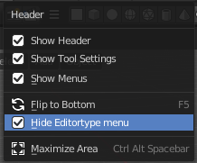

Sub Modes

The Image Editor has three submodes. View, Paint and Mask.

View Mode
It is as the name says a pure view mode. You can view your content.

Paint Mode
Paint mode allows to paint at your image material.

Mask Mode
This mode comes with masking functionality. You can mask out parts of the image.

